Symmetric Wavy Shapes

Definition
# Source: AI Source: Provided by: [Data Path: Persons Table -> ID Column: 1, Name_En Column: Motasem Essam] -> From: [ChatGPT] on [7/25/2026]
A Symmetric Wavy Shape is a wavy shape that remains unchanged when subjected to a specified symmetry transformation.
Its wave pattern is arranged so that corresponding parts of the shape match according to a symmetry, such as:
- Reflection symmetry
- Rotational symmetry
- Point symmetry
Symmetry and regularity are different properties. A symmetric wavy shape can be regular or irregular.
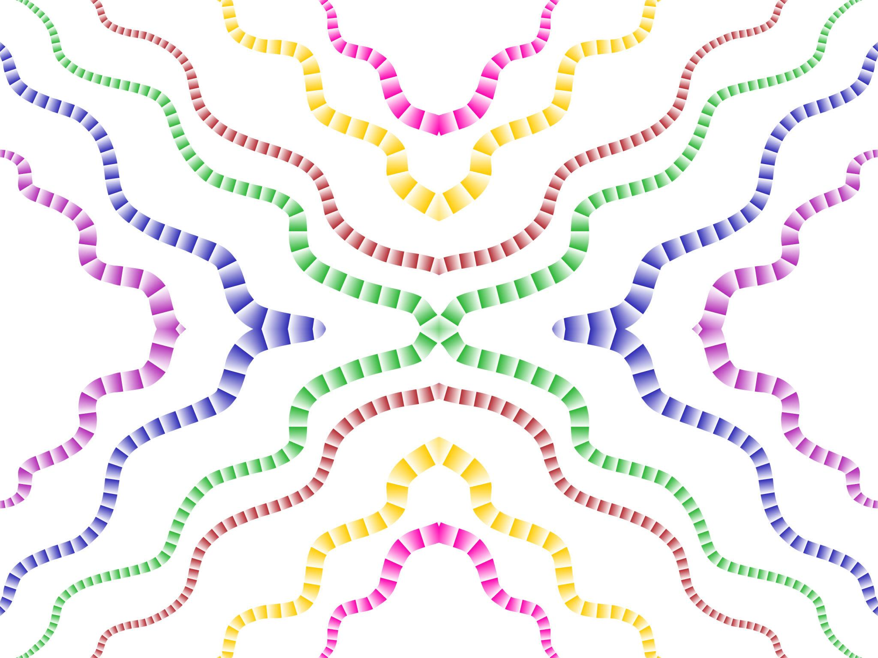
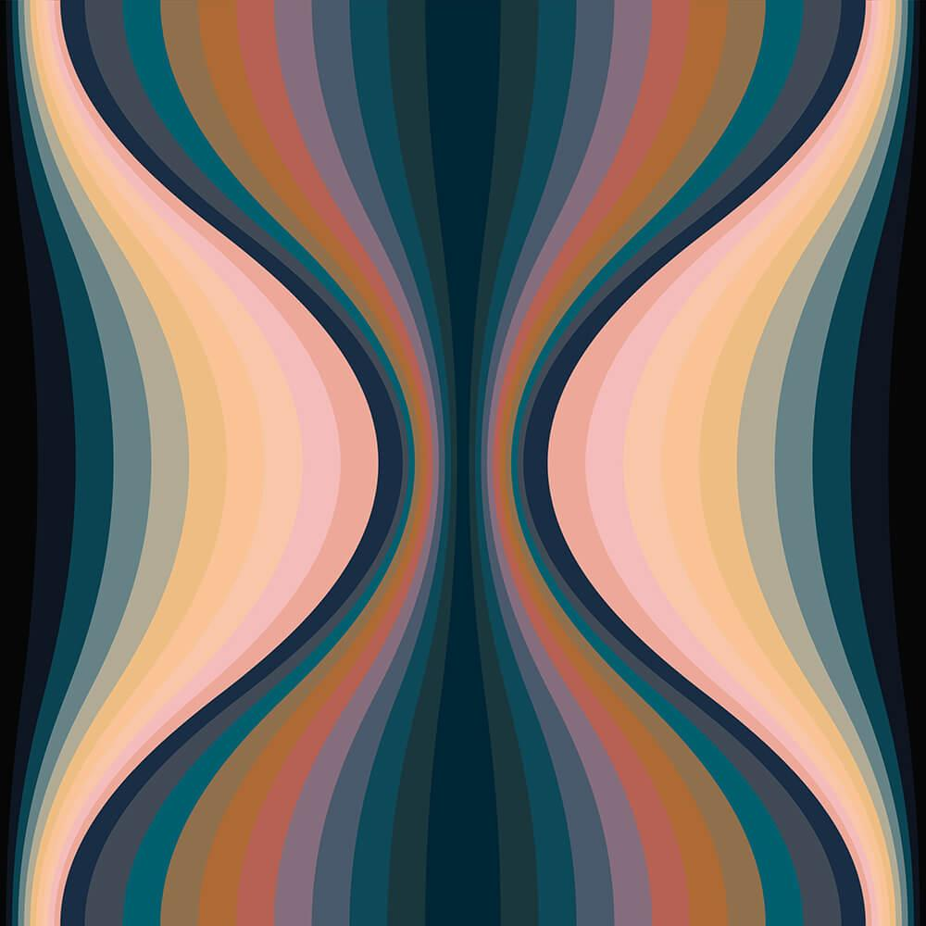
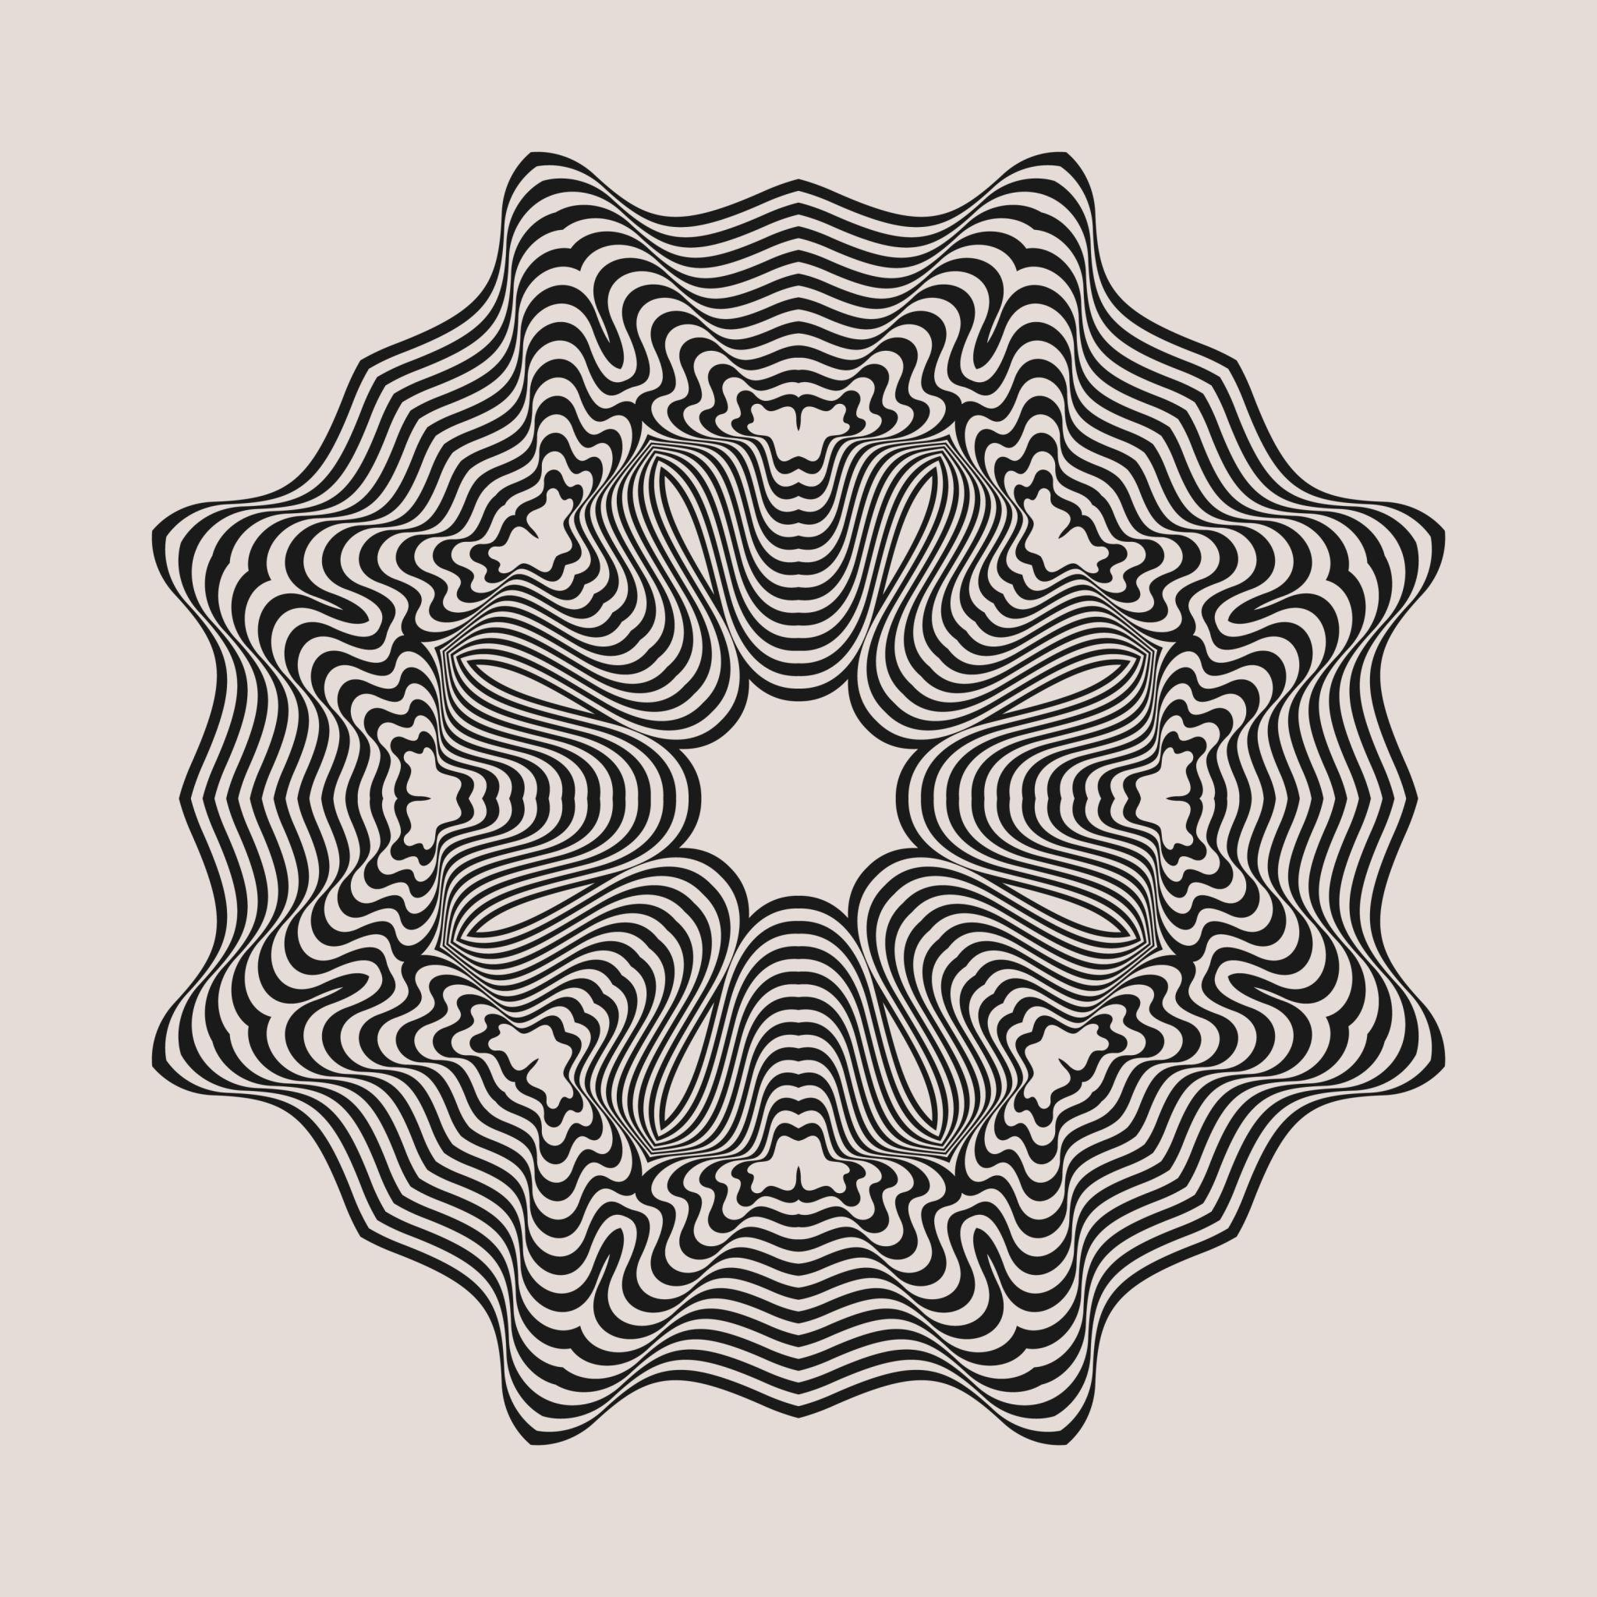
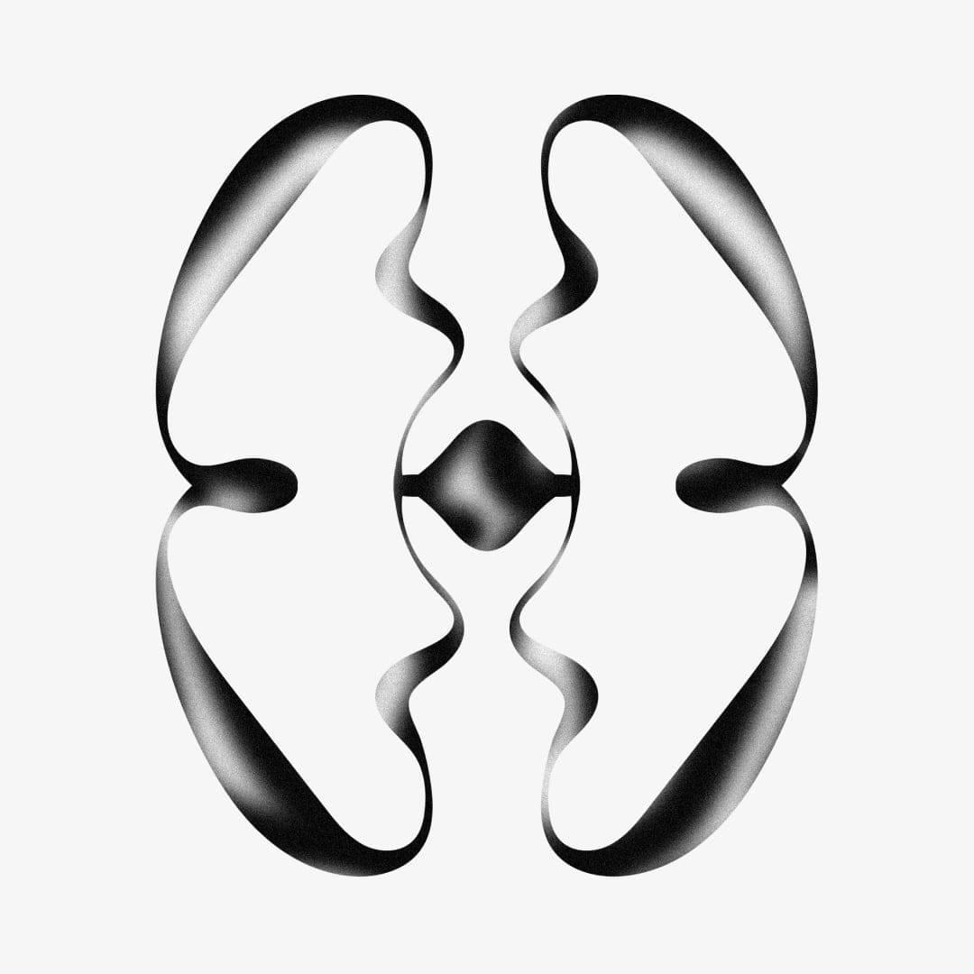
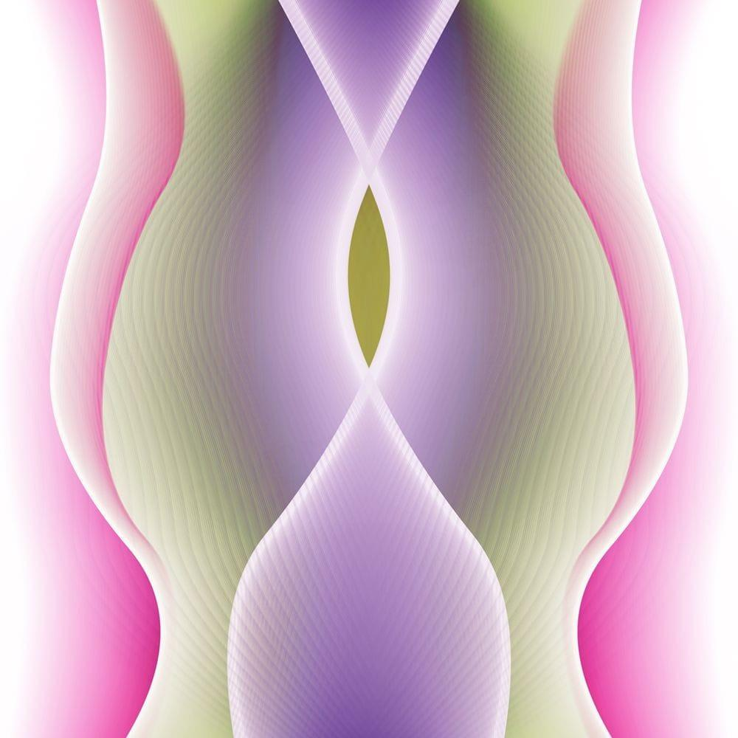
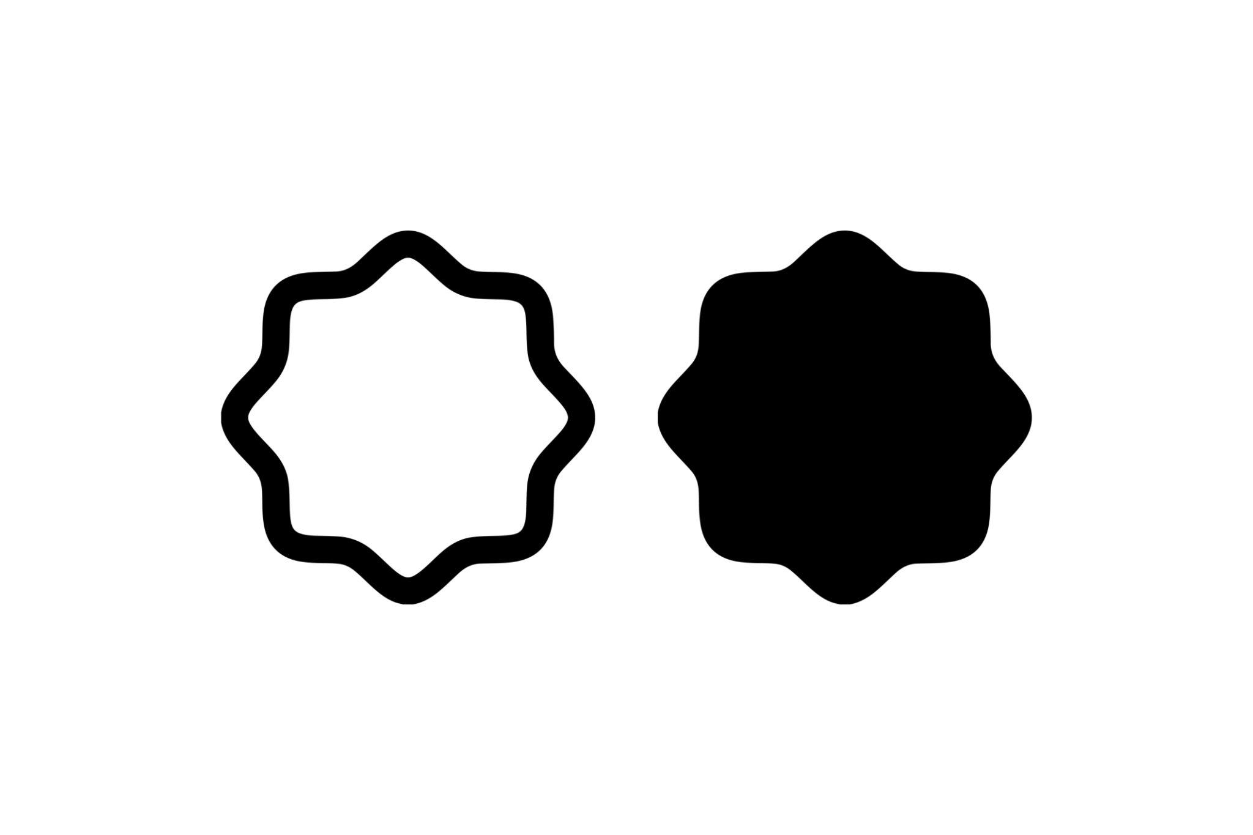

Fundamental Concept
# Source: AI Source: Provided by: [Data Path: Persons Table -> ID Column: 1, Name_En Column: Motasem Essam] -> From: [ChatGPT] on [7/25/2026]
The essential idea is that a transformation maps the shape onto itself.
If $S$represents the shape and $T$represents a symmetry transformation, then:
$$T\left(S\right)=S$$
For example, if reflection across a vertical axis leaves the shape unchanged, the shape has reflection symmetry about that axis.
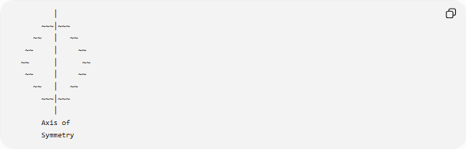
│
~~~│~~~
~~ │ ~~
~~ │ ~~
~~ │ ~~
~~ │ ~~
~~ │ ~~
~~~│~~~
│
Axis of
Symmetry

Main Characteristics
# Source: AI Source: Provided by: [Data Path: Persons Table -> ID Column: 1, Name_En Column: Motasem Essam] -> From: [ChatGPT] on [7/25/2026]
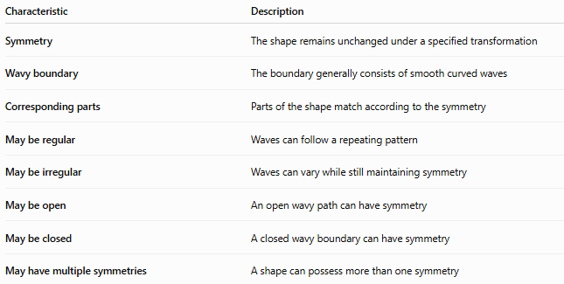
Characteristic | Description
Symmetry | The shape remains unchanged under a specified transformation
Wavy boundary | The boundary generally consists of smooth curved waves
Corresponding parts | Parts of the shape match according to the symmetry
May be regular | Waves can follow a repeating pattern
May be irregular | Waves can vary while still maintaining symmetry
May be open | An open wavy path can have symmetry
May be closed | A closed wavy boundary can have symmetry
May have multiple symmetries | A shape can possess more than one symmetry

Basic Structure
# Source: AI Source: Provided by: [Data Path: Persons Table -> ID Column: 1, Name_En Column: Motasem Essam] -> From: [ChatGPT] on [7/25/2026]
The most common form is reflection symmetry.
For a vertical axis of symmetry, points on opposite sides correspond:
$$\left(x , y\right)→\left(- , xy\right)$$
If the boundary is represented by a function $y=f\left(x\right)$, vertical reflection symmetry occurs when:
$$f\left(-x\right)=f\left(x\right)$$
This is the mathematical definition of an even function.
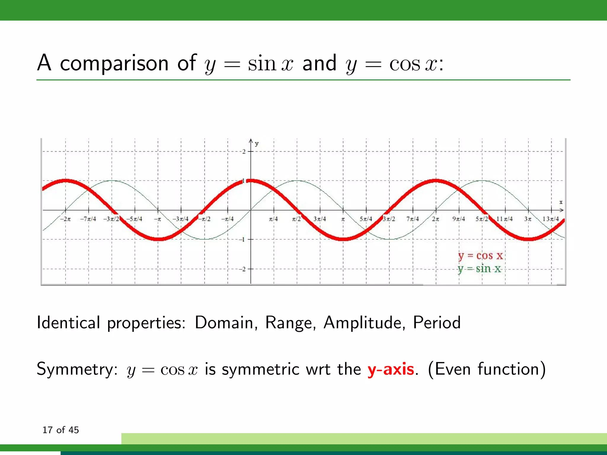
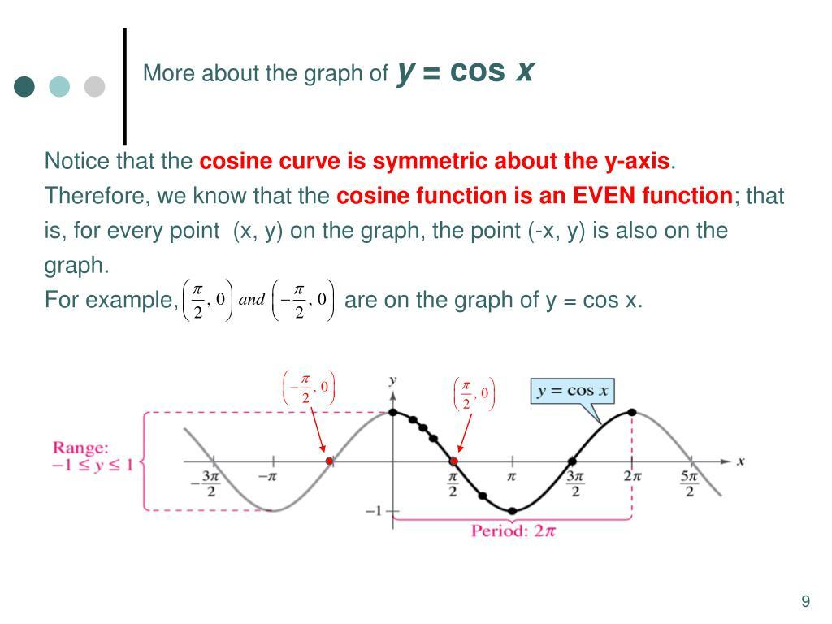
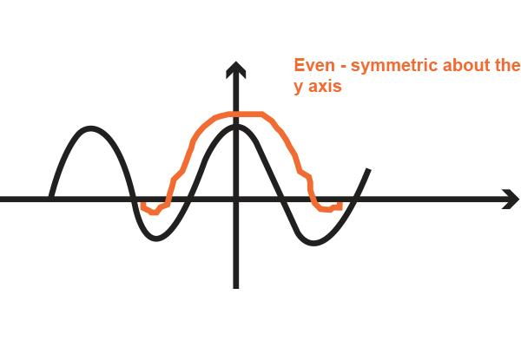
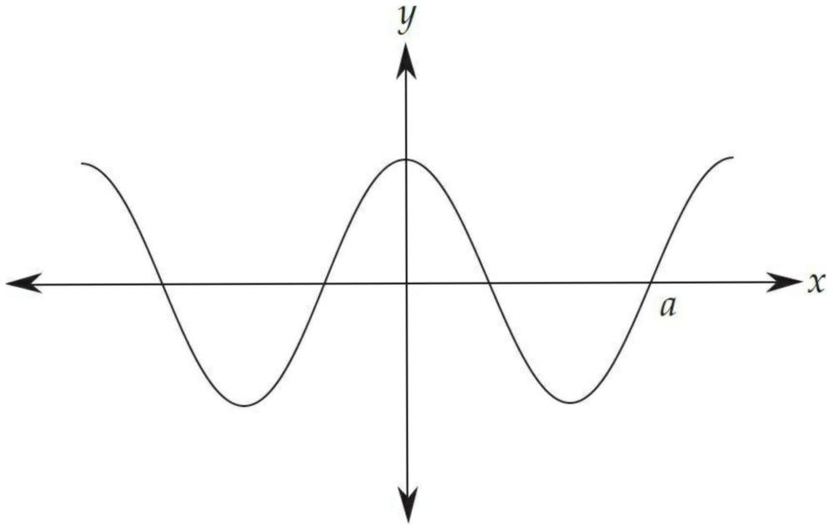
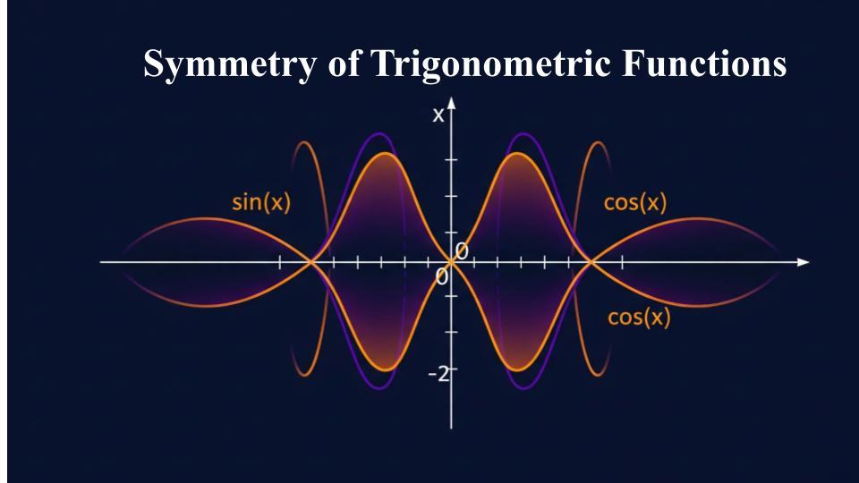
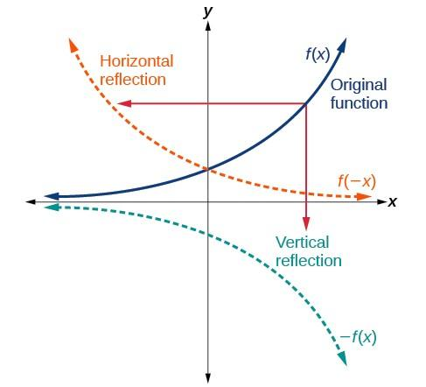

Types of Symmetric Wavy Shapes

1-Reflection-Symmetric Wavy Shapes
# Source: AI Source: Provided by: [Data Path: Persons Table -> ID Column: 1, Name_En Column: Motasem Essam] -> From: [ChatGPT] on [7/25/2026]
A Reflection-Symmetric Wavy Shape has one or more axes of reflection symmetry.
When reflected across its symmetry axis, the shape coincides with itself.
For example:
$$\left(x , y\right)→\left(- , xy\right)$$
for reflection across the $y$-axis.
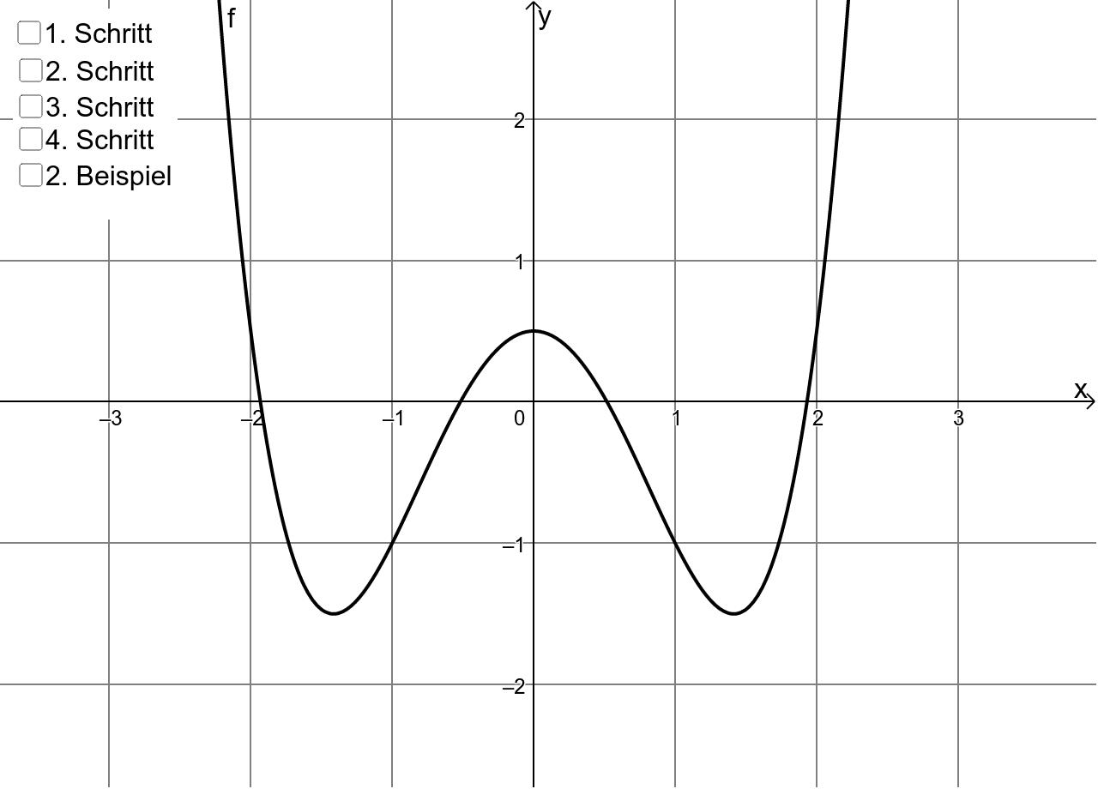
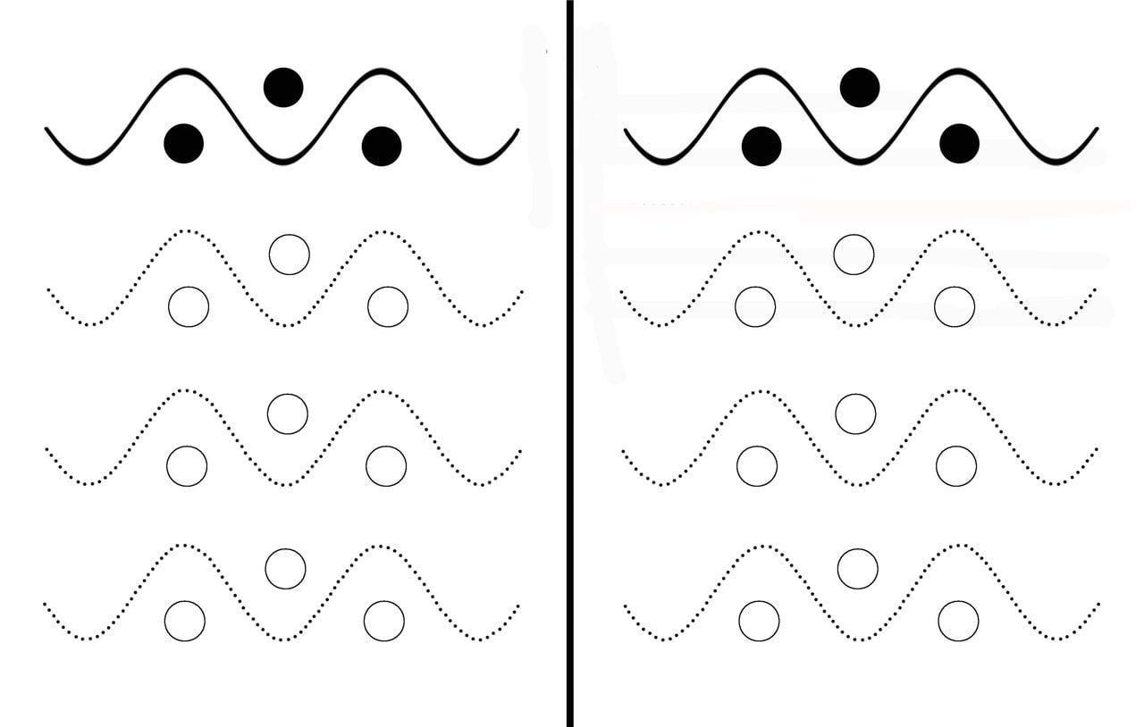

2-Rotationally Symmetric Wavy Shapes
# Source: AI Source: Provided by: [Data Path: Persons Table -> ID Column: 1, Name_En Column: Motasem Essam] -> From: [ChatGPT] on [7/25/2026]
A Rotationally Symmetric Wavy Shape remains unchanged after rotation through a particular angle less than ${360}^{∘}$.
If the smallest angle of rotational symmetry is $θ$, then:
$$θ=\frac{{360}^{∘}}{n}$$
where $n$is the order of rotational symmetry.
For example, a shape with rotational symmetry of order $4$matches itself after:
$$θ=\frac{{360}^{∘}}{4}={90}^{∘}$$
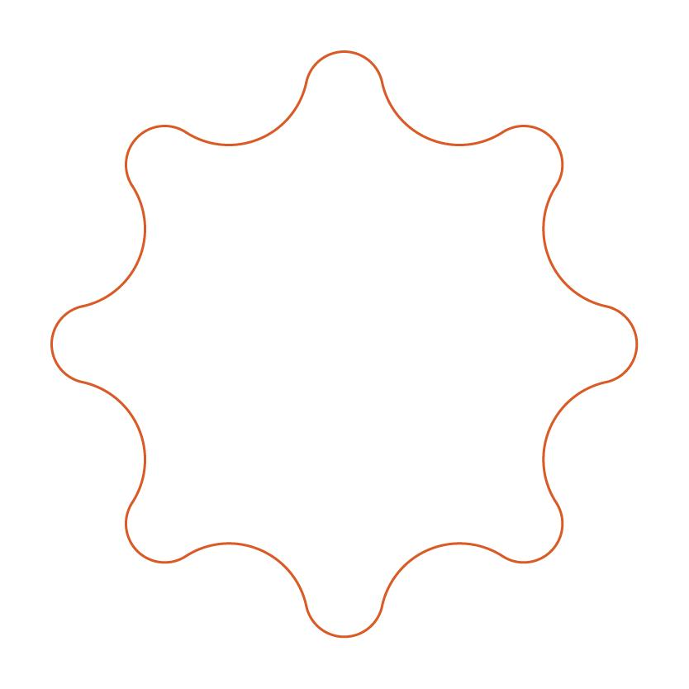
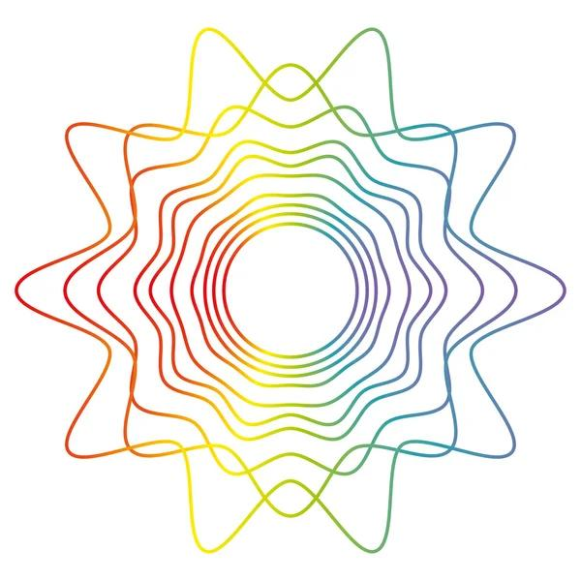
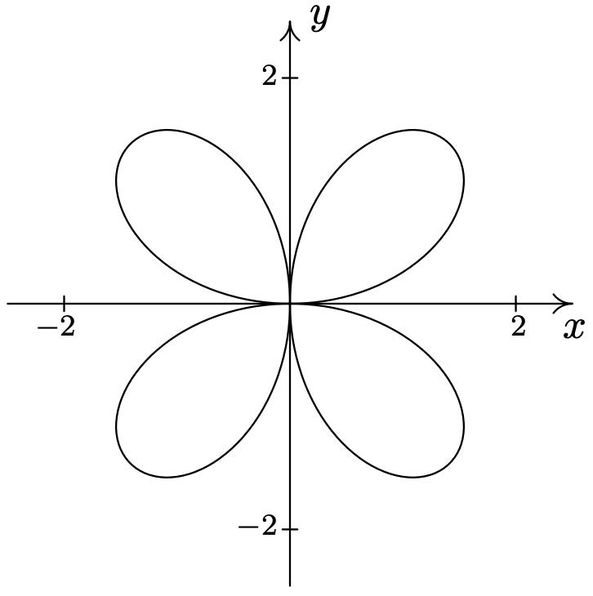
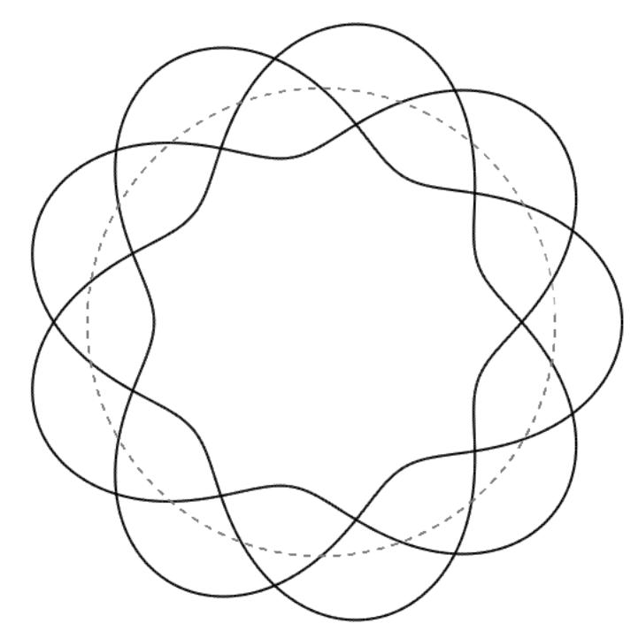
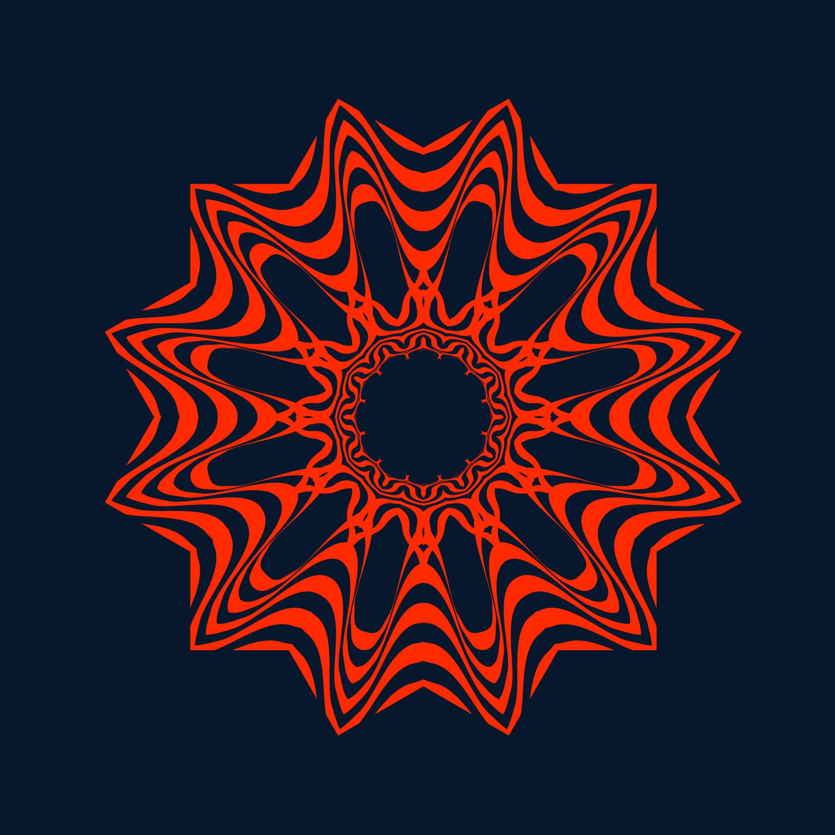

3-Point-Symmetric Wavy Shapes
# Source: AI Source: Provided by: [Data Path: Persons Table -> ID Column: 1, Name_En Column: Motasem Essam] -> From: [ChatGPT] on [7/25/2026]
A Point-Symmetric Wavy Shape has symmetry about a central point.
A ${180}^{∘}$rotation around that point maps the shape onto itself.
For a center at the origin:
$$\left(x , y\right)→\left(- , x-y\right)$$
A corresponding point $P\left(x , y\right)$therefore has a matching point
$$P^{'}\left(- , x-y\right)$$
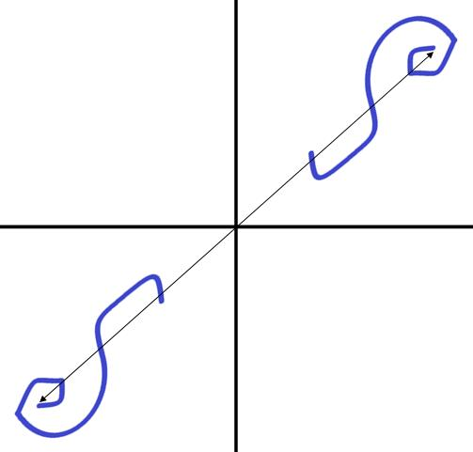
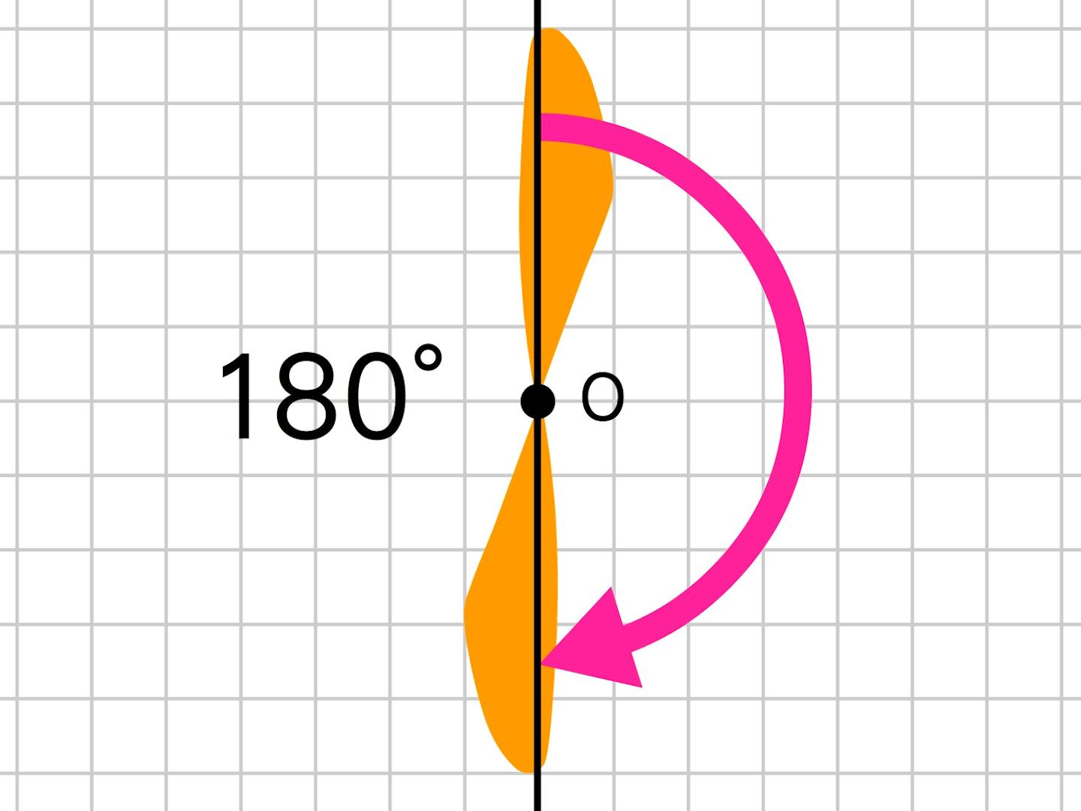
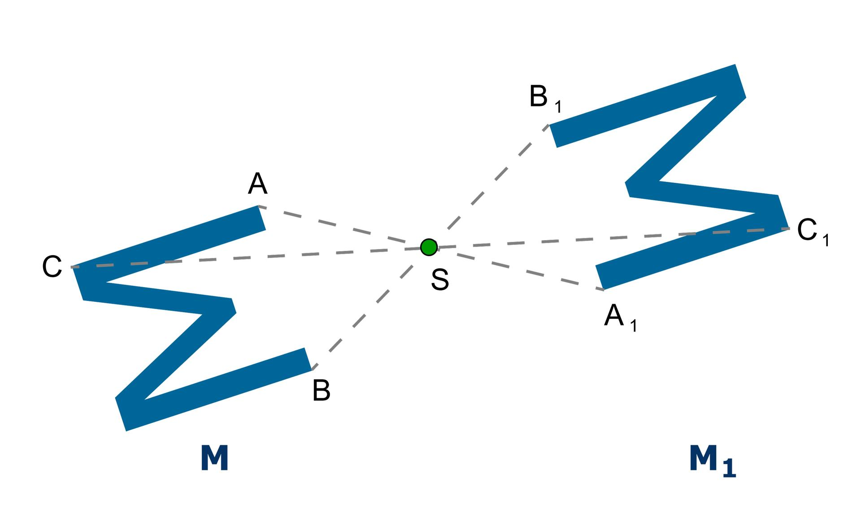

4-Bilaterally Symmetric Wavy Shapes
# Source: AI Source: Provided by: [Data Path: Persons Table -> ID Column: 1, Name_En Column: Motasem Essam] -> From: [ChatGPT] on [7/25/2026]
A Bilaterally Symmetric Wavy Shape has a single principal axis that divides the shape into two matching sides.
This is essentially a form of reflection symmetry.
For example:
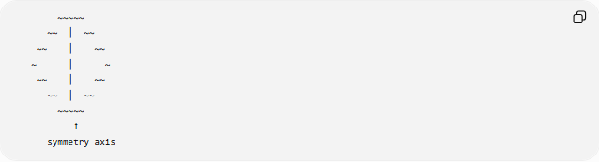
~~~~~
~~ │ ~~
~~ │ ~~
~ │ ~
~~ │ ~~
~~ │ ~~
~~~~~
↑
symmetry axis
This type is common in decorative, natural, and organic forms.

5-Radially Symmetric Wavy Shapes
# Source: AI Source: Provided by: [Data Path: Persons Table -> ID Column: 1, Name_En Column: Motasem Essam] -> From: [ChatGPT] on [7/25/2026]
A Radially Symmetric Wavy Shape has repeated wave features arranged around a central point.
The boundary can be modeled using polar coordinates such as:
$$r=R+Asin⁡\left(nθ\right)$$
where $n$determines the number of repeated wave cycles around the center.
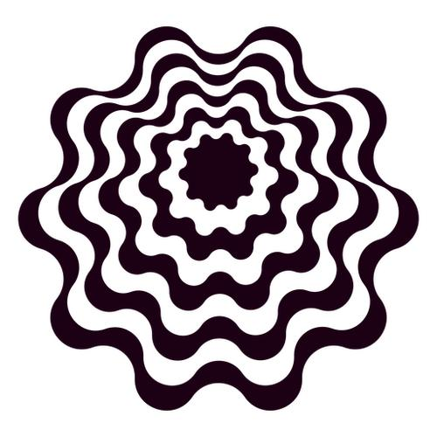
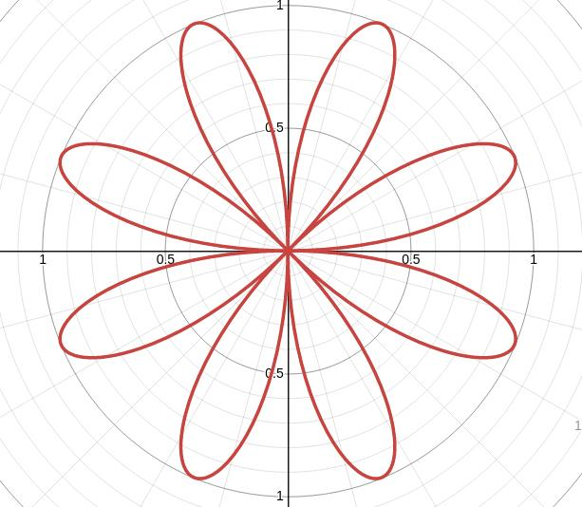
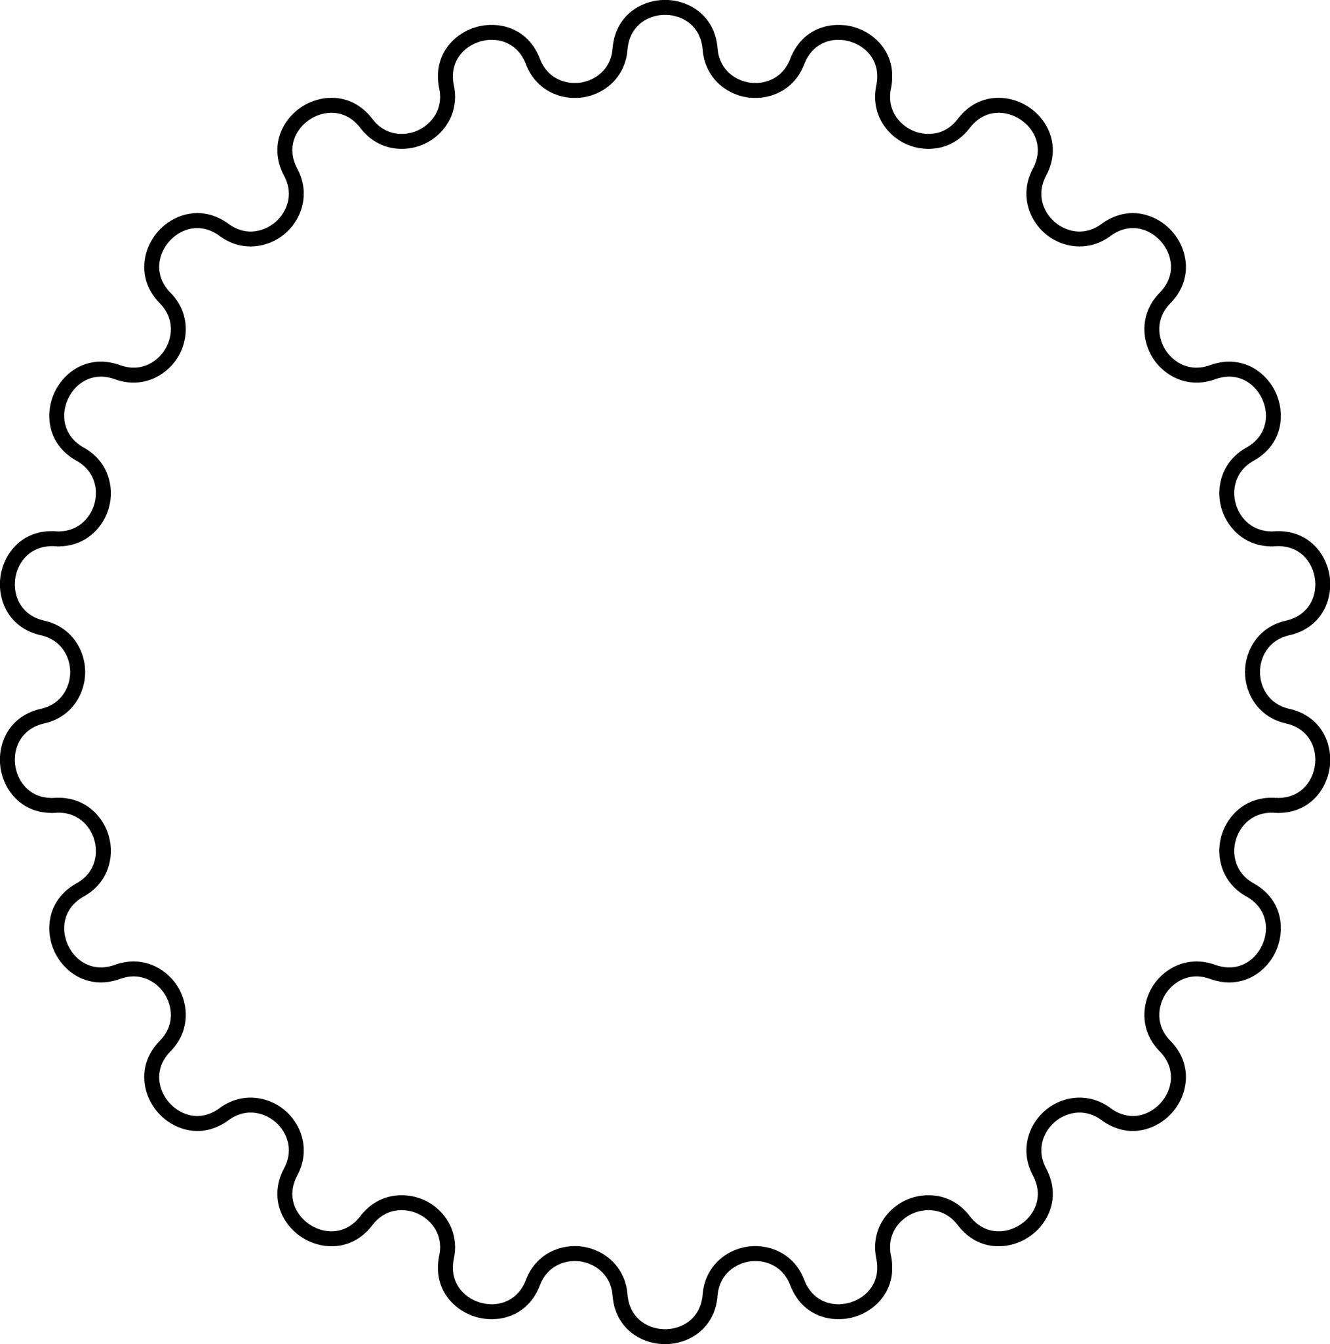
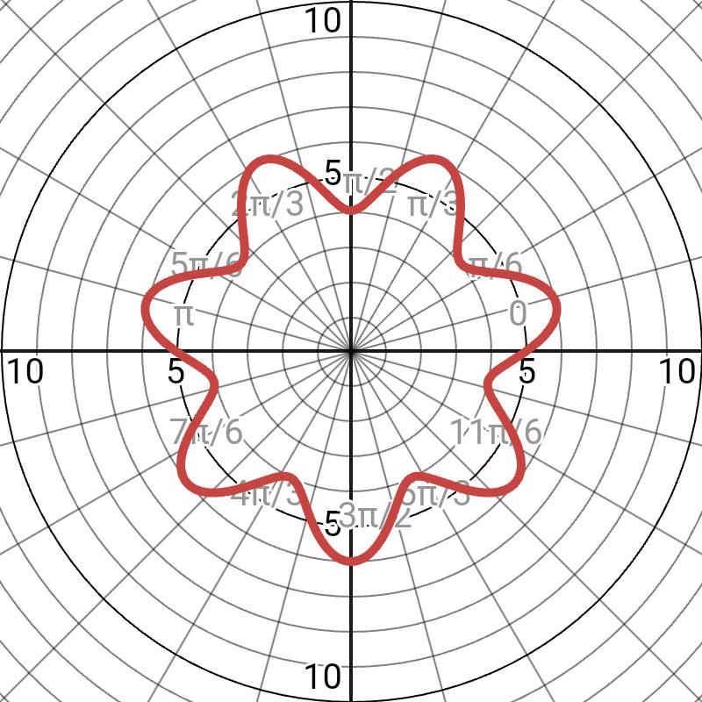

6-Symmetric Open Wavy Shapes
# Source: AI Source: Provided by: [Data Path: Persons Table -> ID Column: 1, Name_En Column: Motasem Essam] -> From: [ChatGPT] on [7/25/2026]
A Symmetric Open Wavy Shape is an open wavy path that has a symmetry.
For example, an open wave can be symmetric about a vertical axis:
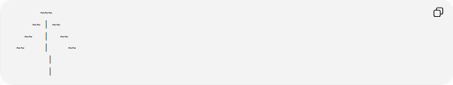
~~~
~~ │ ~~
~~ │ ~~
~~ │ ~~
│
│
The endpoints and corresponding sections must also satisfy the symmetry.
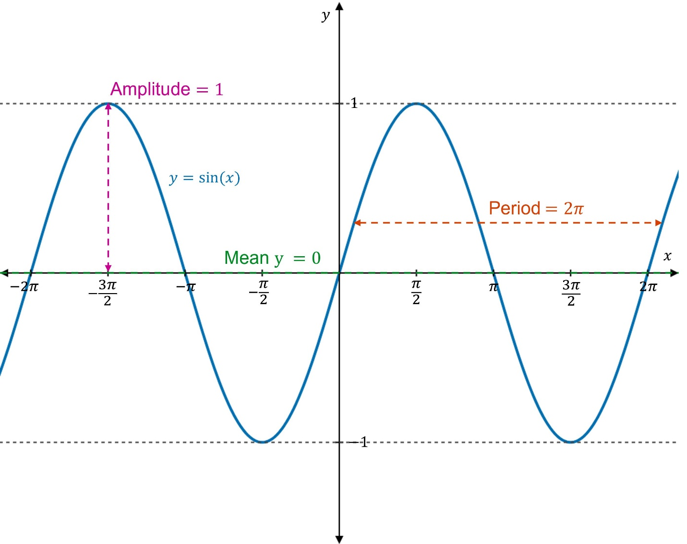
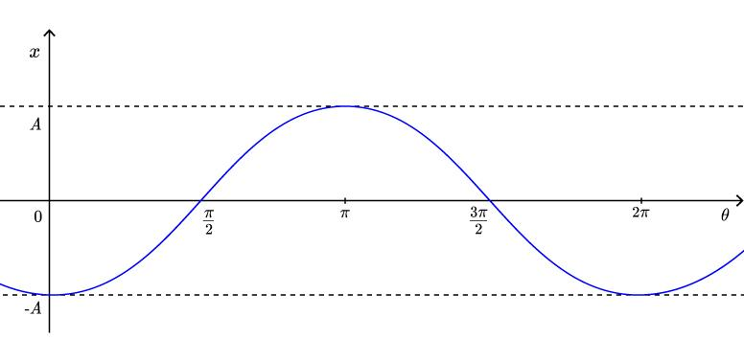
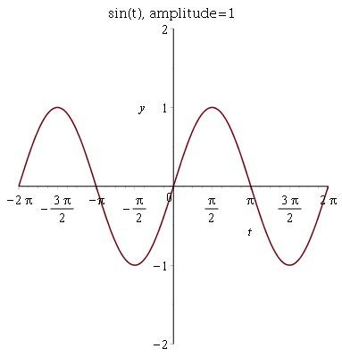

7-Symmetric Closed Wavy Shapes
# Source: AI Source: Provided by: [Data Path: Persons Table -> ID Column: 1, Name_En Column: Motasem Essam] -> From: [ChatGPT] on [7/25/2026]
A Symmetric Closed Wavy Shape has a closed boundary and one or more symmetry transformations.
It encloses a region while maintaining a symmetrical wave arrangement.
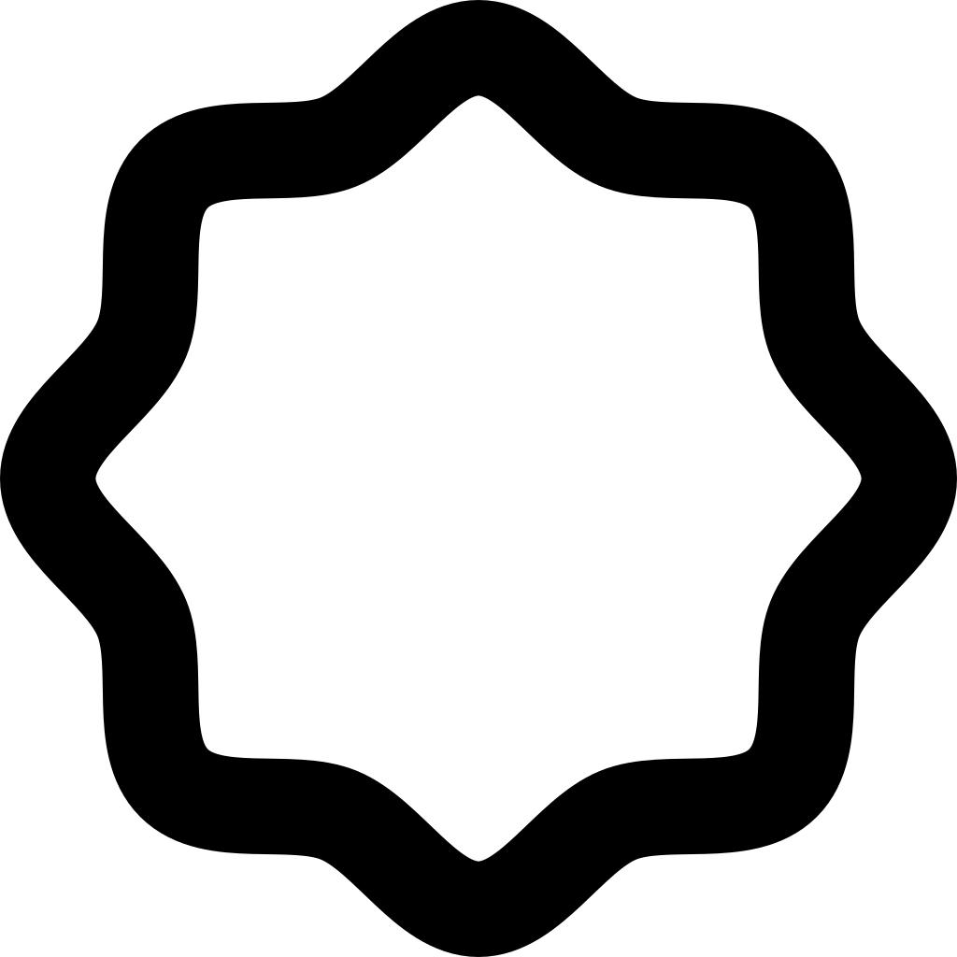
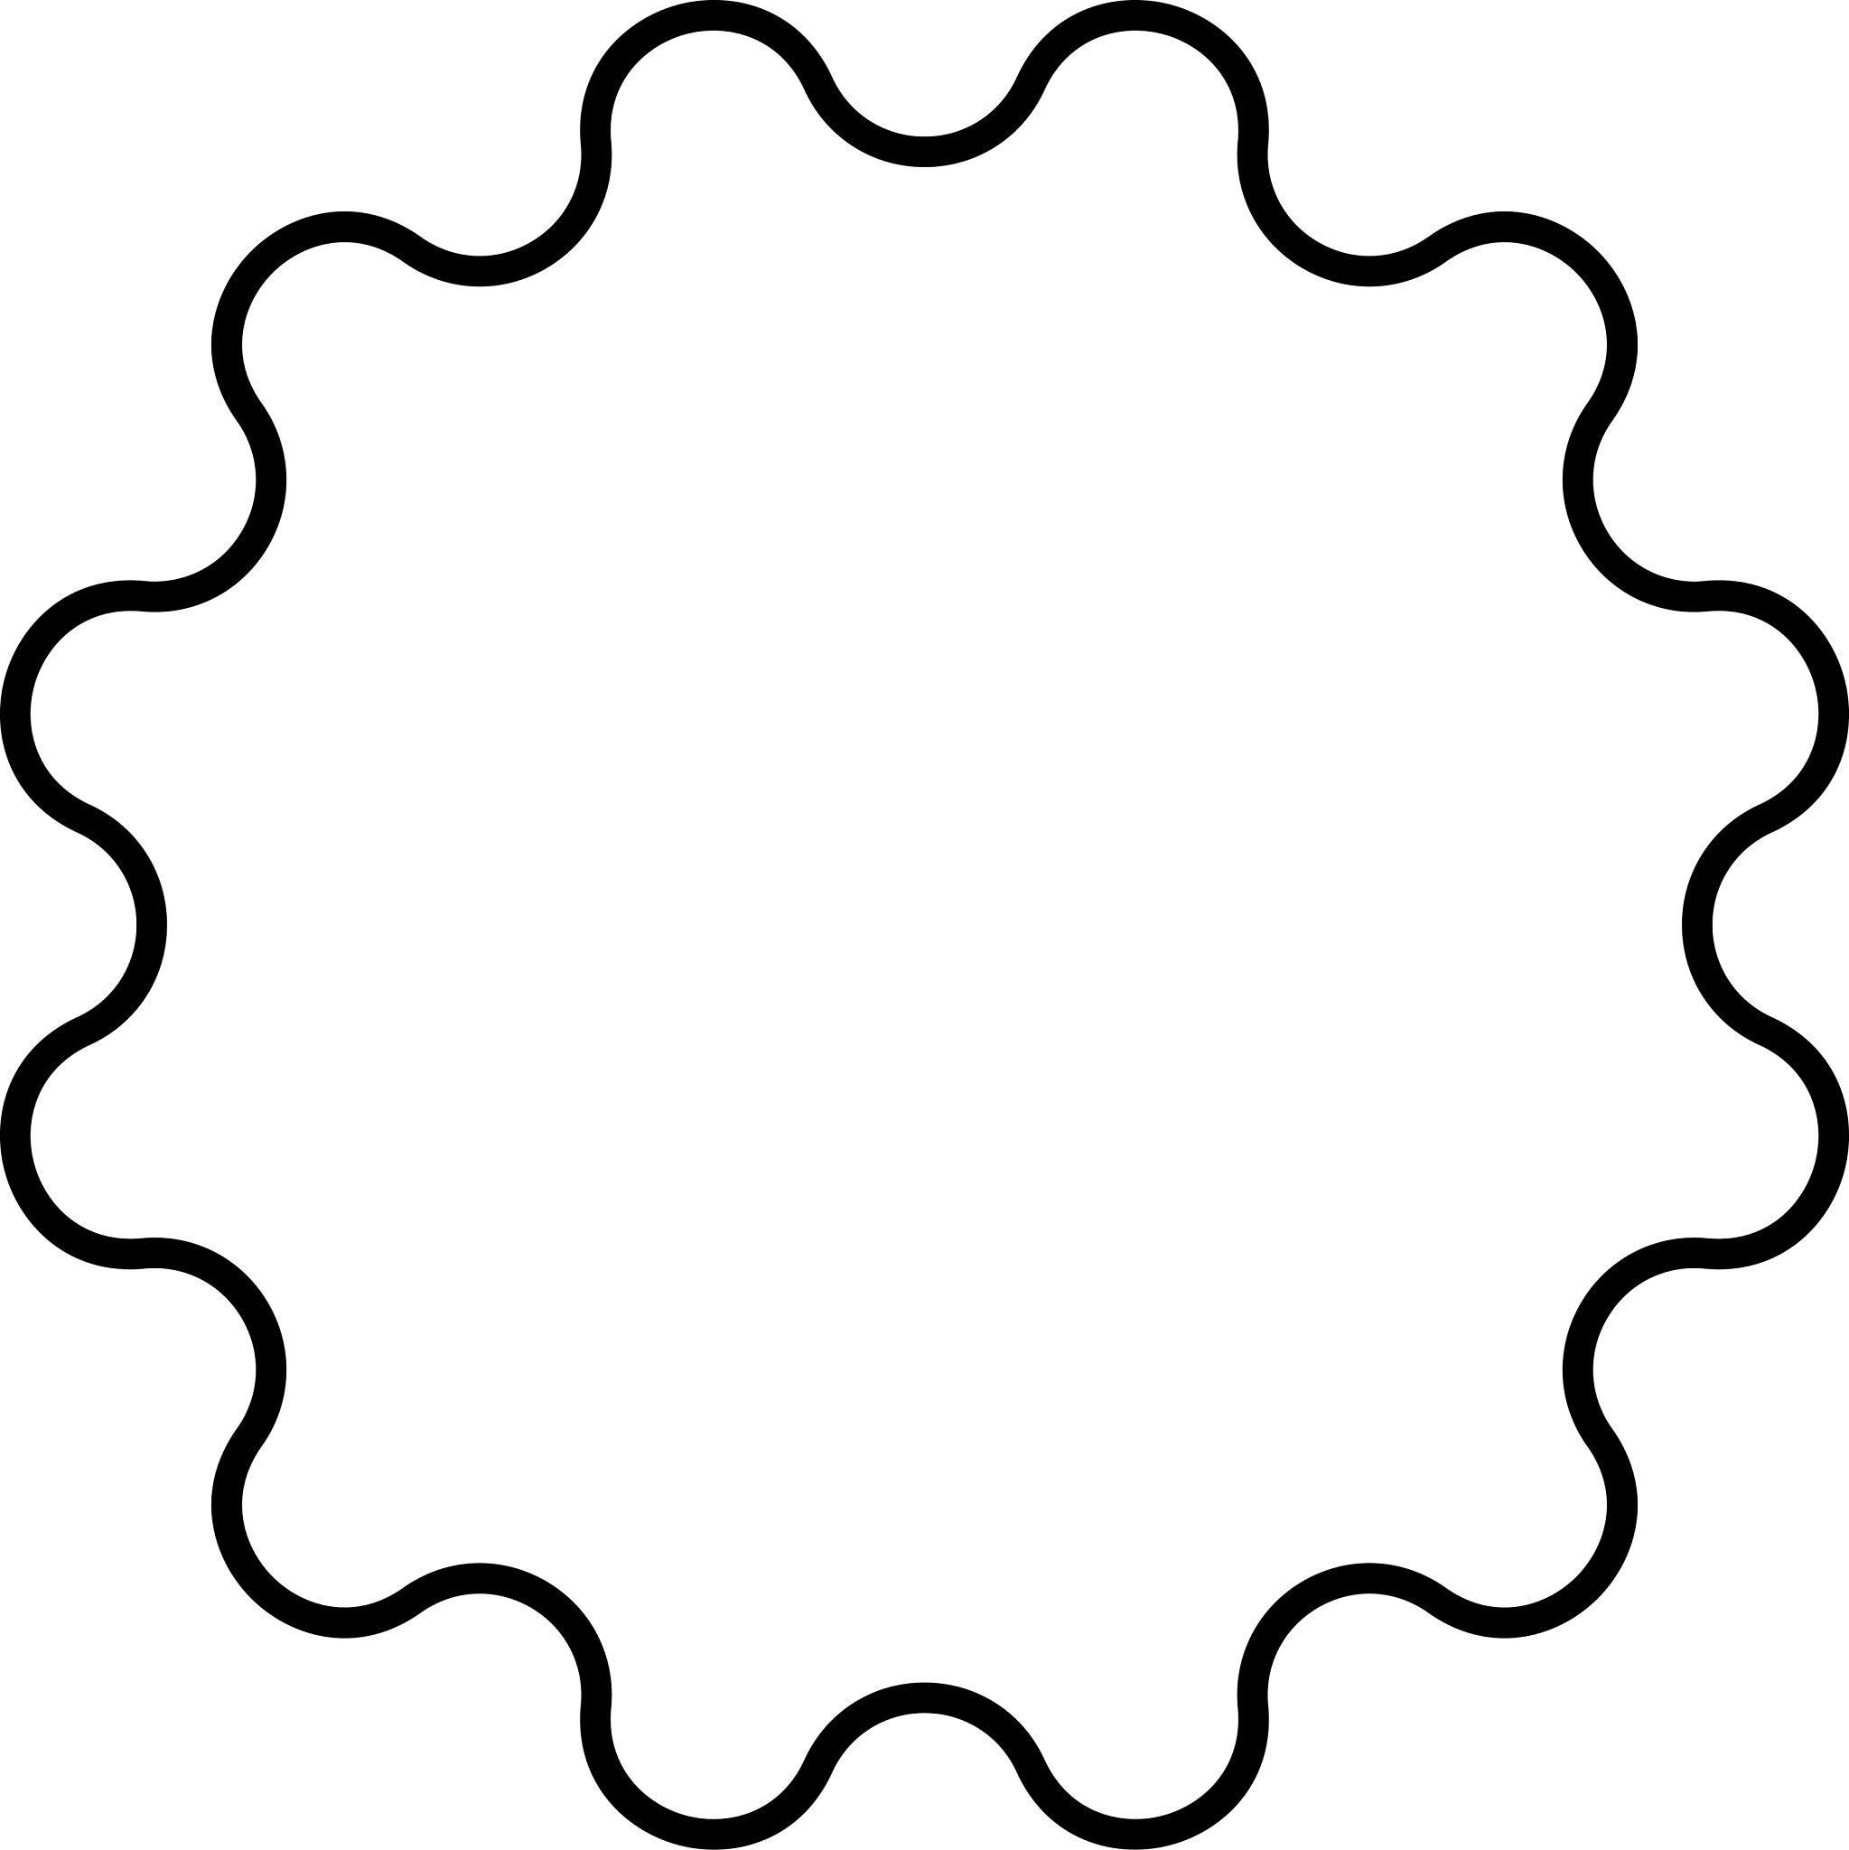
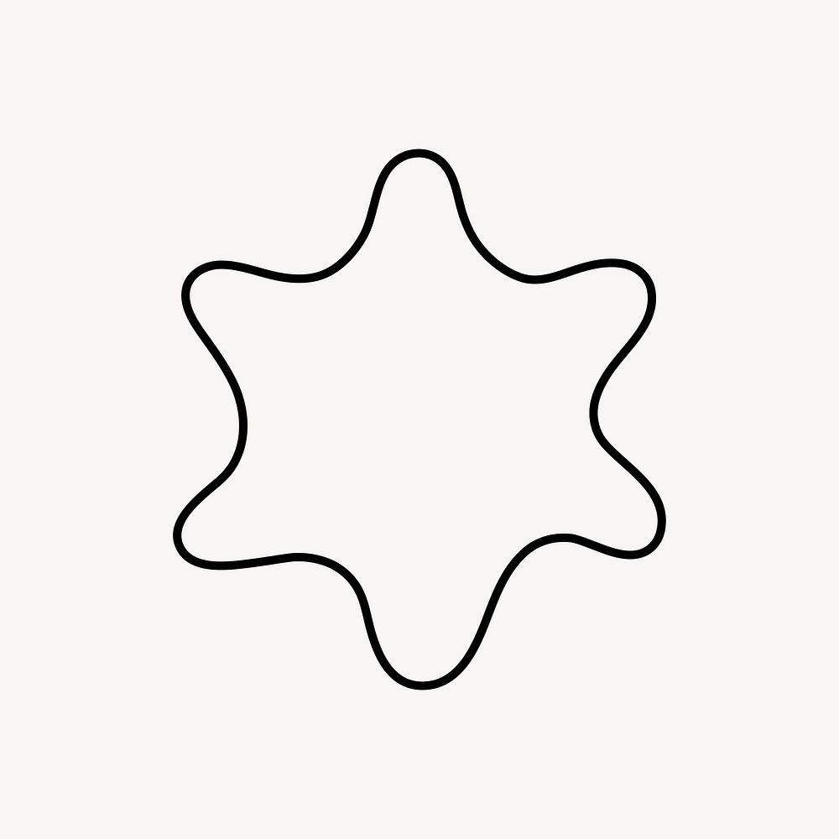


Mathematical Properties

Reflection Symmetry
# Source: AI Source: Provided by: [Data Path: Persons Table -> ID Column: 1, Name_En Column: Motasem Essam] -> From: [ChatGPT] on [7/25/2026]
For reflection across the $y$-axis:
$$\left(x , y\right)→\left(- , xy\right)$$
For a function:
$$f\left(-x\right)=f\left(x\right)$$
indicates symmetry about the $y$-axis.

Rotational Symmetry
# Source: AI Source: Provided by: [Data Path: Persons Table -> ID Column: 1, Name_En Column: Motasem Essam] -> From: [ChatGPT] on [7/25/2026]
A shape has rotational symmetry if a rotation maps it onto itself.
For order $n$:
$$θ=\frac{{360}^{∘}}{n}$$
where $θ$is the smallest positive angle of rotational symmetry.

Point Symmetry
# Source: AI Source: Provided by: [Data Path: Persons Table -> ID Column: 1, Name_En Column: Motasem Essam] -> From: [ChatGPT] on [7/25/2026]
For point symmetry about the origin:
$$\left(x , y\right)→\left(- , x-y\right)$$
For a function, this corresponds to:
$$f\left(-x\right)=-f\left(x\right)$$
which is the property of an odd function.

Closed Symmetric Curves
# Source: AI Source: Provided by: [Data Path: Persons Table -> ID Column: 1, Name_En Column: Motasem Essam] -> From: [ChatGPT] on [7/25/2026]
For a closed parametric curve
$$r\left(t\right)=\left(x , \left(t\right)y\left(t\right)\right)$$
symmetry can be established by finding a transformation $T$such that
$$T\left(S\right)=S$$
where $S$is the complete set of points forming the curve.

Symmetric vs Asymmetric Wavy Shapes
# Source: AI Source: Provided by: [Data Path: Persons Table -> ID Column: 1, Name_En Column: Motasem Essam] -> From: [ChatGPT] on [7/25/2026]
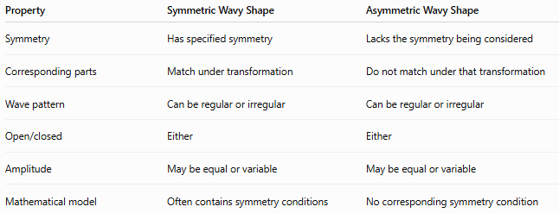
Property | Symmetric Wavy Shape | Asymmetric Wavy Shape
Symmetry | Has specified symmetry | Lacks the symmetry being considered
Corresponding parts | Match under transformation | Do not match under that transformation
Wave pattern | Can be regular or irregular | Can be regular or irregular
Open/closed | Either | Either
Amplitude | May be equal or variable | May be equal or variable
Mathematical model | Often contains symmetry conditions | No corresponding symmetry condition
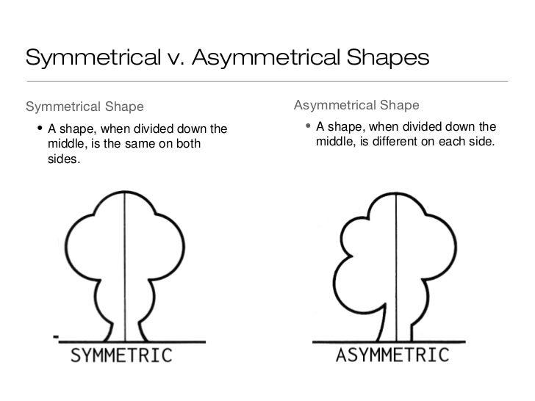
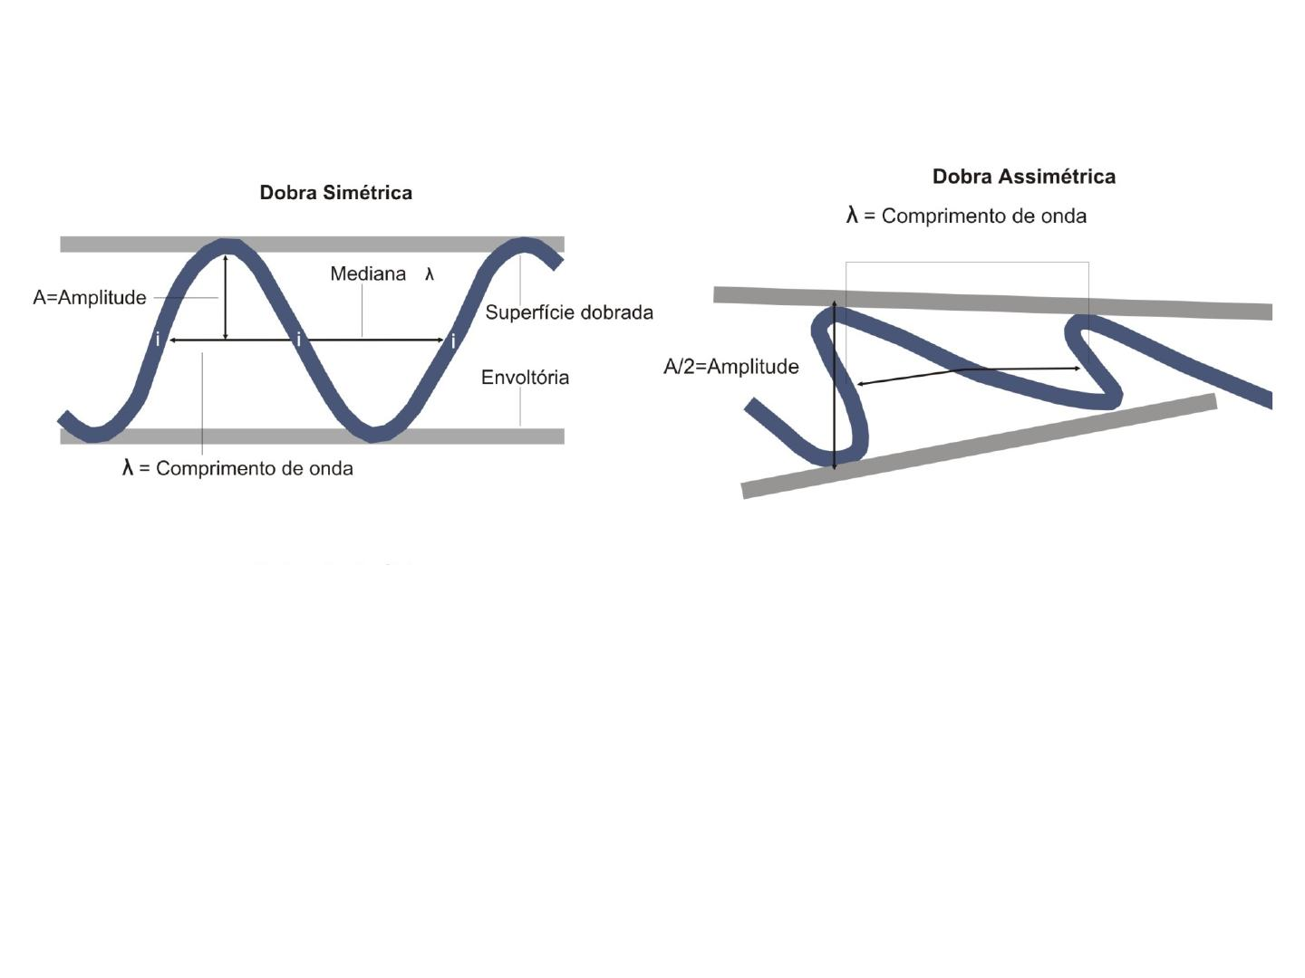
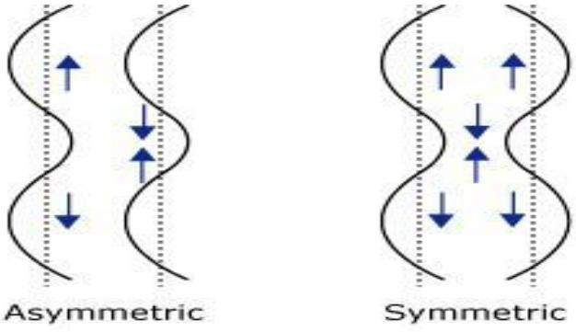

Symmetric vs Regular Wavy Shapes
# Source: AI Source: Provided by: [Data Path: Persons Table -> ID Column: 1, Name_En Column: Motasem Essam] -> From: [ChatGPT] on [7/25/2026]
These terms describe different properties.
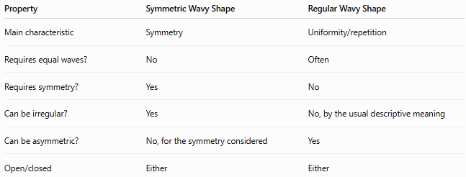
Property | Symmetric Wavy Shape | Regular Wavy Shape
Main characteristic | Symmetry | Uniformity/repetition
Requires equal waves? | No | Often
Requires symmetry? | Yes | No
Can be irregular? | Yes | No, by the usual descriptive meaning
Can be asymmetric? | No, for the symmetry considered | Yes
Open/closed | Either | Either
For example:
An irregular wavy shape can still be symmetric if its irregular features occur in matching pairs.

Examples
# Source: AI Source: Provided by: [Data Path: Persons Table -> ID Column: 1, Name_En Column: Motasem Essam] -> From: [ChatGPT] on [7/25/2026]
Examples of symmetric wavy shapes include:
- A sine-wave curve with reflection symmetry over an appropriate interval.
- A closed wave shape with two mirror-image halves.
- A radially repeated wavy boundary.
- A four-fold rotationally symmetric wave.
- An irregular but mirror-symmetric organic outline.
- An open wavy path symmetric about a central axis.
- A closed wavy shape with multiple axes of symmetry.

Classification Summary
# Source: AI Source: Provided by: [Data Path: Persons Table -> ID Column: 1, Name_En Column: Motasem Essam] -> From: [ChatGPT] on [7/25/2026]
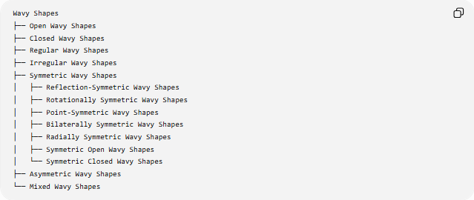
Wavy Shapes
├── Open Wavy Shapes
├── Closed Wavy Shapes
├── Regular Wavy Shapes
├── Irregular Wavy Shapes
├── Symmetric Wavy Shapes
│ ├── Reflection-Symmetric Wavy Shapes
│ ├── Rotationally Symmetric Wavy Shapes
│ ├── Point-Symmetric Wavy Shapes
│ ├── Bilaterally Symmetric Wavy Shapes
│ ├── Radially Symmetric Wavy Shapes
│ ├── Symmetric Open Wavy Shapes
│ └── Symmetric Closed Wavy Shapes
├── Asymmetric Wavy Shapes
└── Mixed Wavy Shapes
Important Classification Note
These categories are not mutually exclusive.
For example, one shape can simultaneously be:
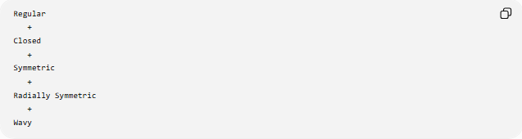
Regular
+
Closed
+
Symmetric
+
Radially Symmetric
+
Wavy
Another can be:
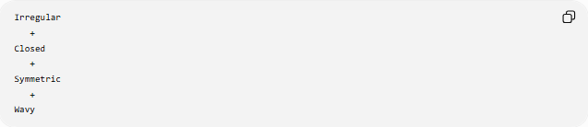
Irregular
+
Closed
+
Symmetric
+
Wavy
So symmetry is an independent geometric property, not an alternative to regularity or irregularity.

Key Points
# Source: AI Source: Provided by: [Data Path: Persons Table -> ID Column: 1, Name_En Column: Motasem Essam] -> From: [ChatGPT] on [7/25/2026]
- A Symmetric Wavy Shape remains unchanged under a specified symmetry transformation.
- The most common type is reflection symmetry.
- Other forms include rotational symmetry and point symmetry.
- Symmetric wavy shapes can be open or closed.
- They can be regular or irregular.
- Symmetric does not mean regular.
- An irregular wavy shape can still be symmetric.
- A symmetry transformation satisfies:
$$T\left(S\right)=S$$
- Reflection about the $y$-axis corresponds to:
$$f\left(-x\right)=f\left(x\right)$$
- Point symmetry about the origin corresponds to:
$$f\left(-x\right)=-f\left(x\right)$$

Conclusion
# Source: AI Source: Provided by: [Data Path: Persons Table -> ID Column: 1, Name_En Column: Motasem Essam] -> From: [ChatGPT] on [7/25/2026]
A Symmetric Wavy Shape is a wavy form whose geometry remains unchanged under one or more specified symmetry transformations. Its symmetry may be reflective, rotational, or point-based, while its wave pattern may be regular or irregular. Therefore, symmetry describes how corresponding parts of a shape relate to one another, whereas regularity describes how consistently its wave pattern repeats.

